Linear Function Worksheet Name: _______________________

Question 1


Step | 1 | 2 | 3 | 4 | 5
Number of Matches
Rule:

Question 2



Step | 1 | 2 | 3 | 4 | 5
Number of Matches
Rule:

Question 3



Step | 1 | 2 | 3 | 4 | 5
Number of Matches
Rule:

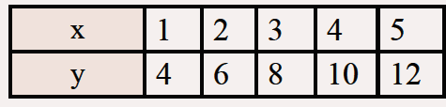
Question 4

What is the rule for the following table?

